|  |
| --- |
| Modules: |
| 01.jpg  02.jpg  03.jpg  04.jpg  05.jpg |

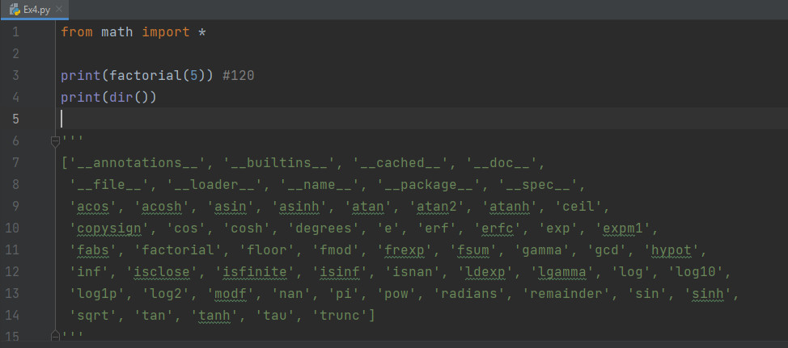

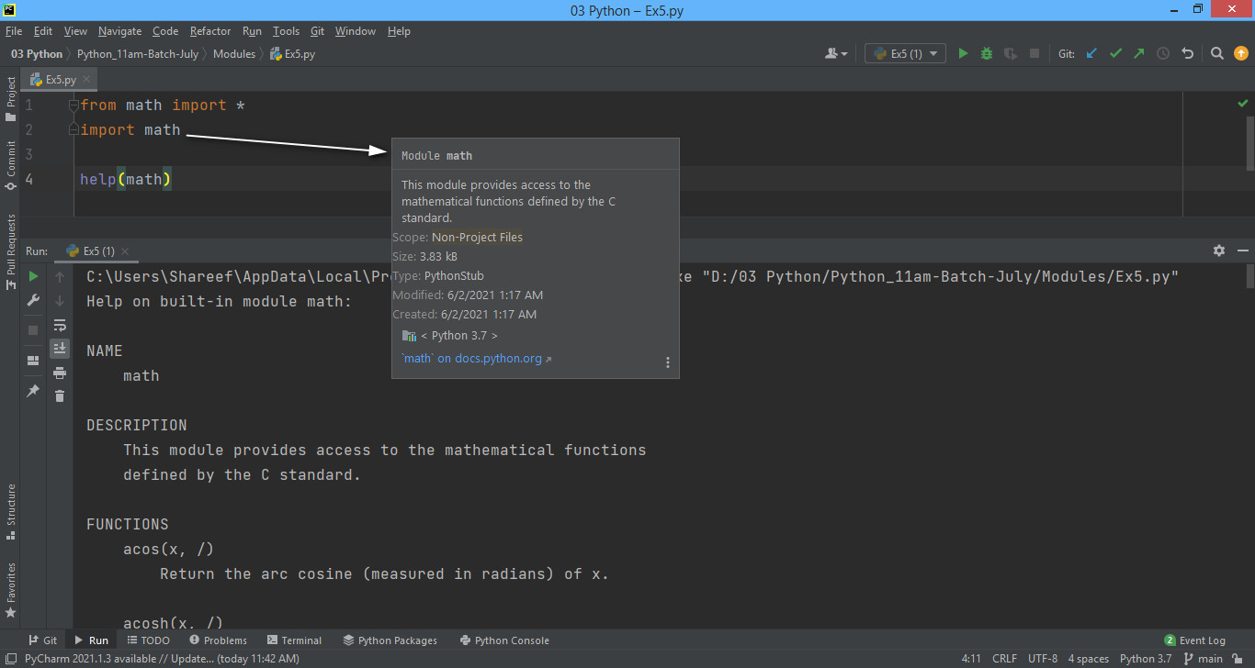

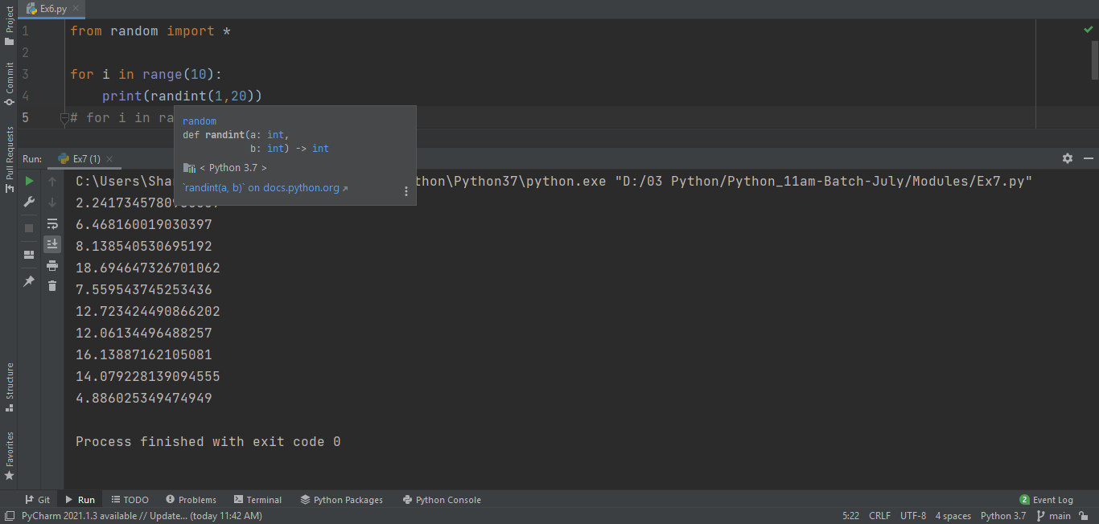

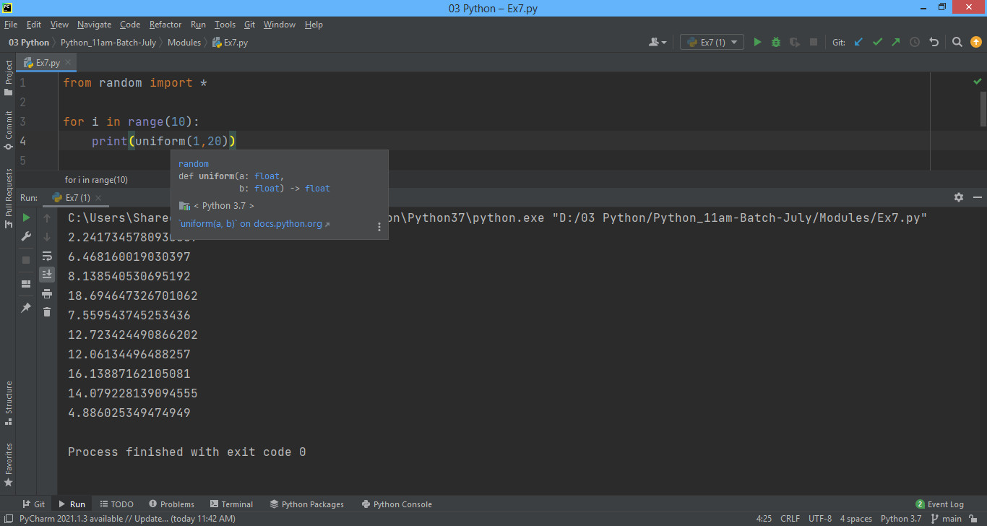

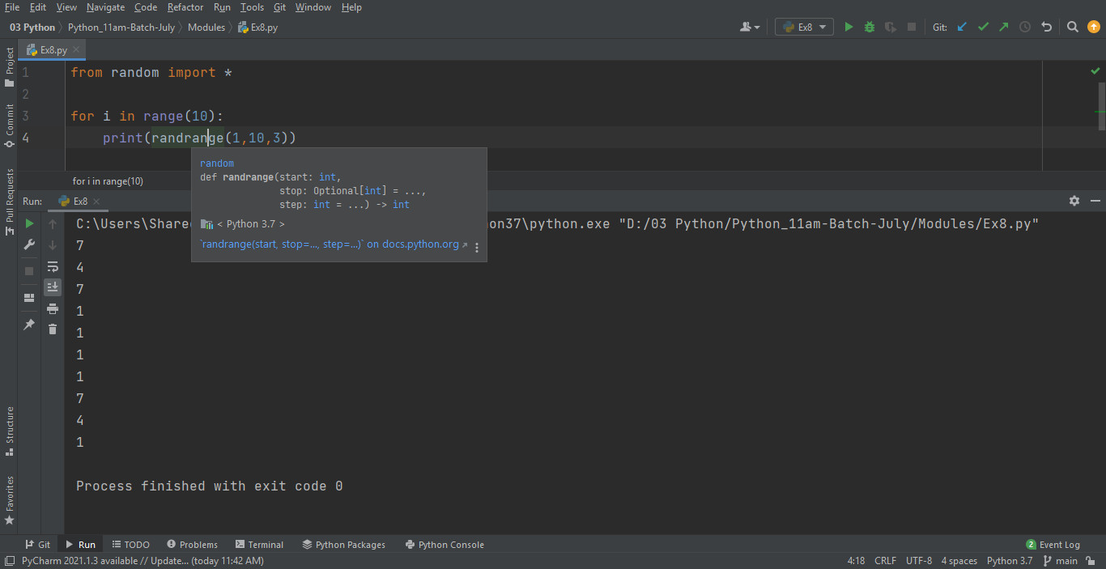

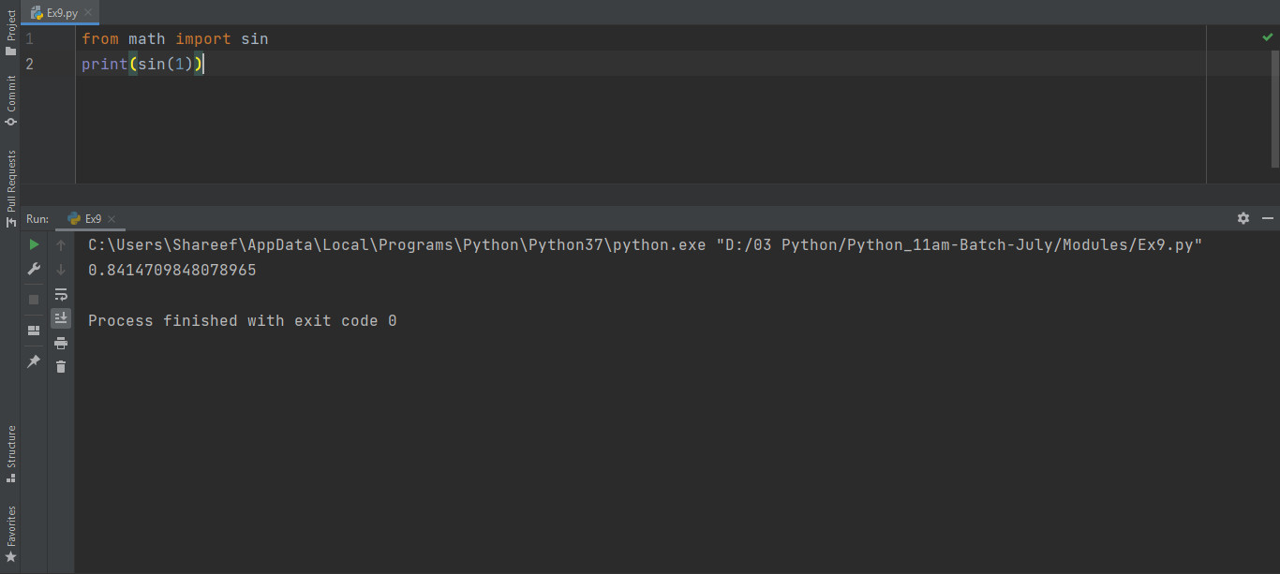

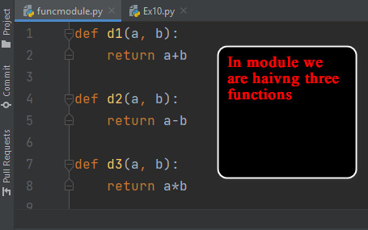 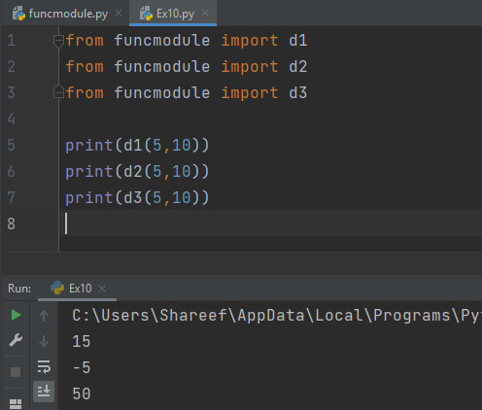

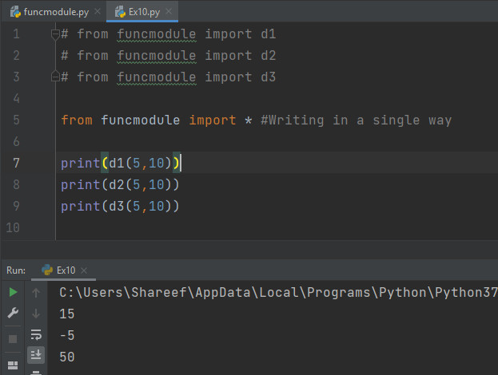

|  |
| --- |
| import random  print(max(2,1,3)) #3 print(min(2,1,3)) #1  print(max(2,1,3,-7)) #3 print(min(2,1,3,-7)) #-7  print(pow(4,2))#16 print(pow(4,2,2)) #base, exp, modulus #0  print(random.random()) #0.9679587134645916 |

|  |
| --- |
| import random  lst = ['A','B','C','D', 'E', 'F', 'G']  #Return a random element from the non-empty sequence seq. If seq is empty, raises IndexError. print(random.choice(lst))  01.jpg  02.jpg  03.jpg |